Lab Exercise 1: Retrieving Data Using the SQL SELECT Statement

By using HR Schema in Oracle Express Edition, answer the following SQL questions.

1. Find the unique locations in departments table. (1 Mark)

1. Select the ID, name and location for all of the departments. (1 Mark)

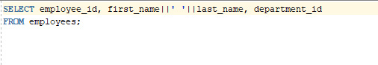

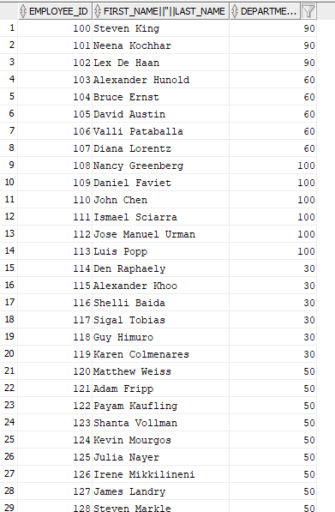

1. Find the ID, last name, salary and new salary for all of the employees. All of the employees’ salary are increased 13%. (2 Marks)



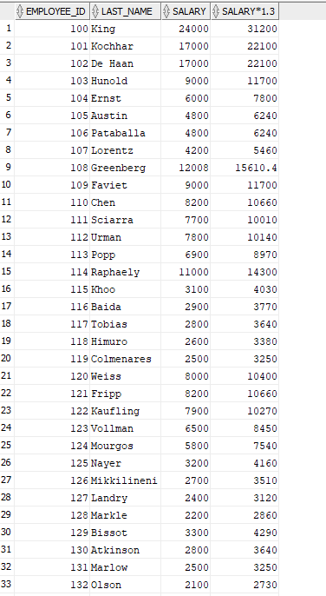

1. Combine the last name and first name for all of the employees. Make sure that the name is separated by space (‘ ‘) for each employee. (2 Marks)

Eg: Steven King

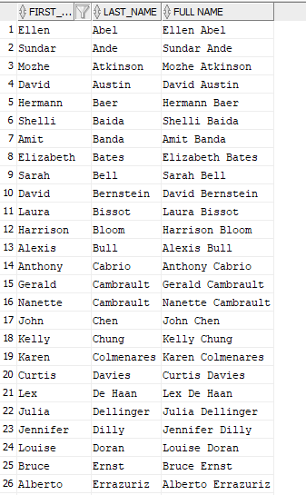

1. “IT’s department is managed by 103”

Show the SQL for the output as above. (2 Marks)

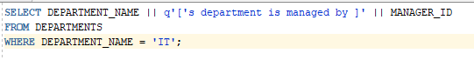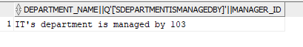

1. Find the yearly salary for each employee. Rename the column to Annual_Salary. (2 Marks)

